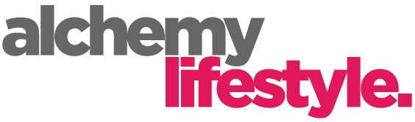
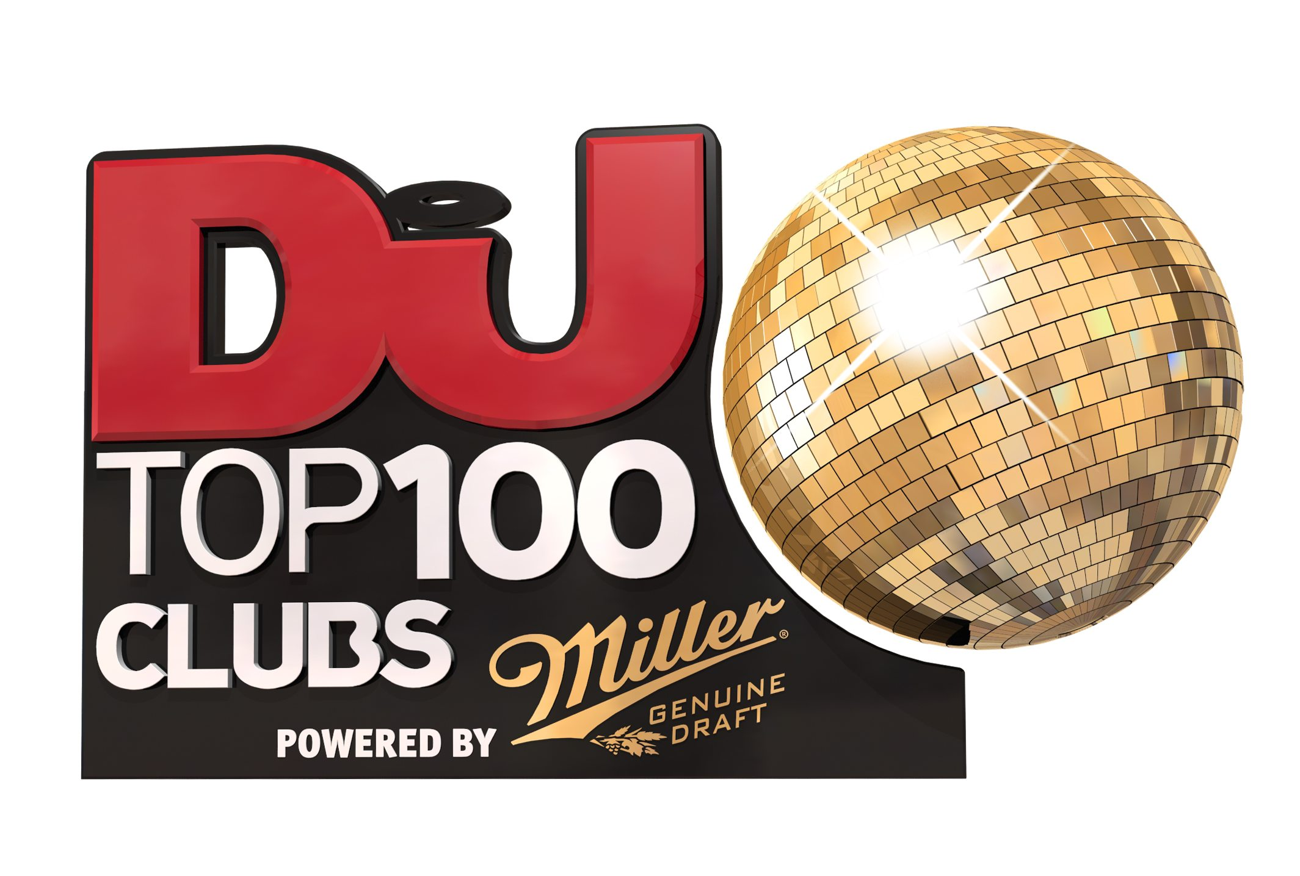

Worlds End Studios
132-134 Lots Road
Chelsea, London SW10 0RJ
Tel: 020 3198 7233 Email: name@alchemylifestyle.co.uk

SPACE IBIZA VOTED WORLD’S NO.1 CLUB 2016
- DJ MAG ANNOUNCES THE RESULTS OF THE TOP 100 CLUBS POLL 2016 POWERED BY MILLER GENUINE DRAFT
- OVER 450,000 VOTES CAST

FULL DETAILS: http://www.djmag.com/top100clubs
www.djmag.com | www.facebook.com/djmagazine |www.twitter.com/djmag

A record-breaking number of votes have been counted and the results are in for DJ Mag’s Top 100 Clubs Poll 2016 powered by Miller Genuine Draft. The Top 100 Clubs Poll is the definitive list of the best clubs on earth – from small intimate venues to huge, large-scale temples to electronic music – and this year’s edition has a new winner, Space Ibiza. The results were unveiled via a social media countdown on DJ Mag’s Twitter and Facebook.

Over 450,000 votes were cast in the Top 100 Clubs Poll 2016, with clubbers voting from across the world. This year’s victory marks Space Ibiza’s fourth win, beating their own record from 2014. However, 2016 will be the final time you’ll see the legendary venue in the Top 100 Clubs Poll, as this will be the venue's final year of operation. Widely regarded as one of the greatest clubs of all time, the Ibiza superclub has stood on the same site for over 25 years, and will close its doors at the end of the summer.

With the 100 clubs coming from 36 different countries, the Top 100 Clubs Poll 2016 is more representative than ever of the global clubbing scene. These spaces - including supervenues and bastions of the underground alike - are the lifeblood of electronic music; their dancefloors play an incredibly important role in shaping new sounds, scenes and genres, hosting renowned resident DJs, rising new talent and huge international names alike, and creating cultural waves that reach far beyond their walls.

BRAZIL
Space Ibiza regained the top spot this year from Brazil’s Green Valley, which was voted in at No.2. It has been another incredible year for the club scene in Brazil, with seven clubs in the Top 50, the South American nation’s position as the most powerful emerging clubbing force in the world is safe for another year.

AMERICA
For the first time in the poll’s history, America has the highest number of ranked clubs (16). Five Las Vegas venues feature in the poll, including Omnia, who are this year’s Highest New Entry. In New York, Verboten and Output both feature, pointing to a thriving underground scene in The Big Apple. It’s not all about the traditional US cities either. Washington’s Echostage is a standout performer in 2016, climbing to No.13 in this year’s poll.

IBIZA & NEW NATIONS
With Space taking the top spot, and three of the island’s clubs in the Top 5, The White Island is as strong as ever.

However, this year’s poll welcomes new venues in Indonesia and Thailand, while China is proving that ‘superpower’ is an apt term for their club scene as well as their economy.

The arrival of White Club, in Dubai, means that UAE finally have a ranked club. The thriving club scene in The Emirates suggests that more clubs could follow in the future.

Elsewhere, it’s a welcome return to the poll for Sydney’s Chinese Laundry. The dance music institution is one of Australia’s longest running nightclubs. Their inclusion in this year’s poll marks a return for the country, which had no ranked venues in 2015.

For further information on the Top 100 Clubs Poll 2016 please contact:
matt@alchemylifestyle.co.uk 07966781138 or james@alchemylifestyle.co.uk 07515709916

1 Space Ibiza Ibiza
2 Green Valley Brazil
3 Amnesia Ibiza
4 Pacha Ibiza
5 Octagon S.Korea
6 Zouk Singapore
7 Hakkasan Las Vegas
8 Ushuia Ibiza
9 Sirena Brazil
10 BCM Majorca
11 Papaya Croatia
12 DC10 Ibiza
13 Echostage Washington
14 Paradise Club Mykonos
15 fabric London
16 Berghain/Panorama Bar Berlin
17 Bootshaus Cologne
18 Anzu Brazil
19 Motion Bristol
20 Noa Beach Club Croatia
21 Warung Brazil
22 Cavo Paradiso Mykonos
23 Ministry of Sound London
24 Guaba Beach Bar Cyprus
25 Cocorico Italy
26 Zouk, KL Kuala Lumpar
27 Sankeys Ibiza Ibiza
28 The Warehouse Project Manchester
29 Baum Colombia
30 Air Amsterdam
31 Digital Newcastle Newcastle
32 Omnia Las Vegas

33 Exchange, LA Los Angeles
34 Arma 17 Moscow
35 Marquee Las Vegas Las Vegas
36 Elrow Barcelona
37 Matahari Brazil
38 Space Miami Miami
39 Barbarellas Croatia
40 El Fortin Brazil
41 Yalta Bulgaria
42 Avalon Los Angeles
43 Icon Miami
44 Guendalina Italy
45 Aquarius Croatia
46 New City Gas Canada
47 Fabrik Madrid Madrid
48 Output New York
49 White Club Dubai
50 Encore & Surrender Las Vegas
51 Versuz Belgium
52 Privilege Ibiza
53 Cacao Beach Bulgaria
54 EGG LDN London
55 Womb Tokyo
56 D-EDGE Brazil
57 Lost Beach Club Equador
58 Lux Lisbon
59 Sub Club Glasgow
60 Myst Shanghai
61 The Palace (formerly Valkyrie) Philippines
62 Beach Club Montreal Montreal
63 Sankeys Manchester Manchester
64 Coliseum Jakarta
65 Elements Beijing
66 Duel Beat Italy
67 Rex Club Paris
68 Watergate Berlin
69 Mint Club Leeds
70 Drais Las Vegas
71 La Huaca Peru
72 Cielo New York
73 E11EVEN Miami
74 Concrete Paris
75 Revelin Croatia
76 XOYO London
77 Tresor Berlin
78 Dragonfly Jakarta
79 The Light Las Vegas
80 Chinese Laundry Sydney
81 Cubic Macau
82 Foundation Seattle
83 Velvet Paraguay
84 Modo Beijing
85 Metropolis Paris
86 M2 Shanghai
87 Phonox London

88 Kitty Su India
89 Razzmatazz Barcelona
90 Ce La Vie Singapore
91 Mad Switzerland
92 Verboten New York
93 Illuzion Thailand
94 Stealth Nottingham
95 CODA Toronto
96 Rainbow Venues Birmingham
97 X2 Jakarta
98 Studio 338 London
99 Space Ibiza New York New York
100 Robert Johnson Frankfurt

ABOUT THE TOP 100 CLUBS POLL

This is the third year that the Top 100 Clubs Poll 2016 has been presented in partnership with leading beer brand Miller Genuine Draft. Miller are long-time supporters of electronic music and have been instrumental in the growth of Top 100 Clubs since launching the partnership in 2014 - specifically in helping to raise awareness of the poll in new and emerging territories for dance music.

DJ Mag are huge supporters of the international nightclub industry, the magazine’s ‘Save Our Club’s’ campaign highlights the positive contribution the nightlife industry makes to global cultural and financial economies, as well as helping club owners and clubbers fight against threats to local and regional venues from increasing gentrification and excessive legislation from state-run authorities.

Top 100 Clubs powered by Miller Genuine Draft is a public vote. No registration is required. Voting takes place at http://vote.top100clubs.com. Voters must verify their identity using, Facebook, Google or email before choosing up to 5 clubs, which are ranked in order from 1 (highest) - 5 (lowest). The club placed in first position gains 5 points, and the club placed in 5th position gains 1 point. The final list is dictated by the 100 clubs with the highest number of points.

For the second successive year, Top 100 Clubs powered by Miller Genuine Draft included a bonus question, asking voters to name their favourite festival. The winner of this vote will be announced in DJ Mag’s Festival Edition, released on 28th April 2016. Last year’s winner was Tomorrowland in Belgium.

ABOUT DJ MAGAZINE
DJ Mag is the world’s leading electronic music magazine, and is translated into over 10 languages every single month. As the guardian of highly influential global polls including Top 100 DJs and Top 100 Clubs, DJ Mag is a globally relevant and hugely influential voice in the electronic music scene.

ABOUT MILLER GENUINE DRAFT
Miller Genuine Draft is one of the smoothest, most refined beers in the world. A premium beer made with the finest ingredients, the unique 4x cold-filtering process produces a beautiful and refined golden lager and incredible smoothness and refreshment - perfect for discovering the high energy nightlife of the world's greatest cities.

